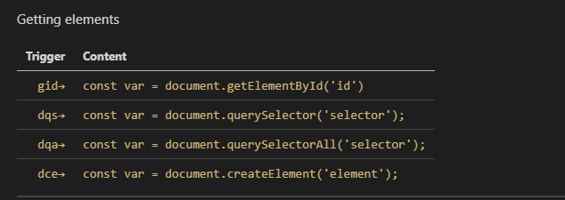

**gid+tab键=》document.getElementById(“id”)**

**dqs+tab键=》document.querySelector(‘selector’);**

**dqa+tab键=》document.querySelectorAll(‘selector’);**

**dce+tab键=》document.createElement(‘element’);**